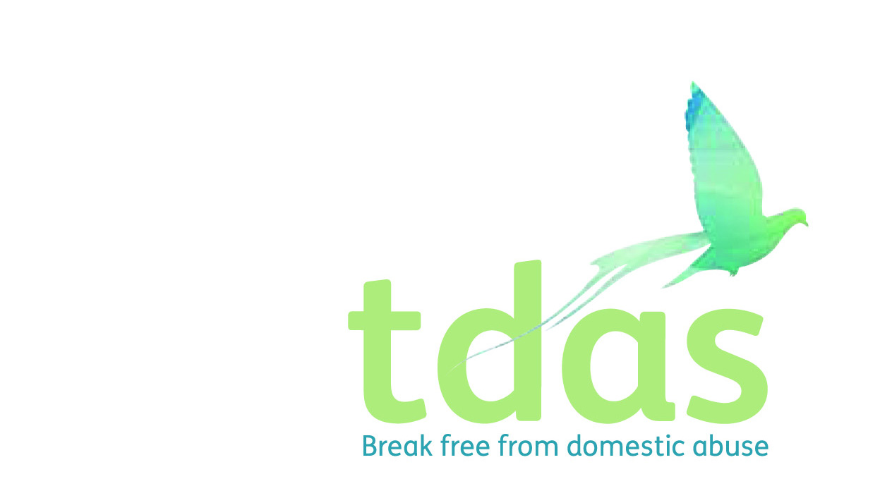

**COMPLAINTS, COMMENTS AND COMPLIMENTS POLICY & PROCEDURE**

TDAS aims to provide a high-quality service to all service users and hopes that service users will have no reason to complain.

As part of our continuing commitment to improve our services, however, the views of residents and service users are listened to and play a positive part in improving its services.

The procedure is in two parts. The first part deals with solving problems informally or listening to comments about our service provision. The second part deals with more serious complaints or comments, which will be dealt with formally

If you do have reason to complain or make a comment about our service provision, then please use the following procedure:

If your complaint/comment is about repairs at the Refuge, dispersed or tier 2 accommodation then please speak to your Support worker for details on who to address your complaint to.

As far as is reasonably possible, the confidential nature of complaints and comments will be respected.

**COMPLIMENTS**

Any verbal or written compliments will be recorded by the member staff receiving the compliment and be passed to the Service Administrator for recording on the Compliments Register. Any member of staff identified as being the subject or contributing to any matter giving rise to the compliment will be notified within ASAP. Feedback on compliments will be shared with employees at appropriate timings.

**AIMS OF THE COMPLAINTS PROCEDURE**

* To encourage comments to be made about our service provision in order to

improve and/or change our services.

* To acknowledge each service user’s rights as a service user
* To encourage discussion and problem solving rather than a defensive response to complaints.
* To set time limits which emphasise the need for swift responses.
* To encourage members of staff to act as an advocate for vulnerable service users.
* To uphold members of staff’s rights.

**HOW TO COMPLAIN**

**STAGE ONE – PROBLEM SOLVING**

This stage aims to resolve complaints and comments by encouraging a problem- solving approach.

If a service user or professional wants to make a complaint or comment they should raise this with a member of staff, making it clear that they are making a complaint. In the Refuge, a complaint/comment can also be left in the Suggestion Box.

If a service user or professional wants to make a complaint or comment about a worker or a volunteer, they should, if they feel able to do so, raise the complaint with the member of staff concerned.

If a service user or professional does not feel able to raise the complaint with a member of staff, they should proceed to stage two.

Complaints and comments will be recorded on the Complaints and Comments Log.

Please note that any service user can ask somebody else to act on their behalf in terms of making a complaint or comment. **We will not, however, deal with any anonymous complaints or comments.**

**THE COMPLAINTS AND COMMENTS LOG**

The Complaints/Comments Log will record the following information:

* Name of the service user/professional making the complaint/comment
* Date and time of the complaint/comment
* Name of the member of staff receiving the complaint/comment
* Reasons for and full details of the complaint/comment
* Agreed action to be taken
* When the complaint/comment is resolved, and the time taken
* Future Learning and action taken

Any problem that is dealt with under Stage One will result in a reply, which will also be logged in the Complaints and Comments log. **The reply will be given in verbal or written form within 10 working days.**

Normal good practice should sort out and resolve complaints, comments and problems that are part of everyday life within the Refuge or are part of the delivery of other support services we provide.

Members of staff may refer to documents such as The Residents’ Information Pack, Policy and Procedures file, House Rules, Licence Agreement, Exclusion Procedure and any other agreed Policies, Procedures and Guidelines for guidance for complaints or comments which can be easily and satisfactorily dealt with.

The Service user or Professional will be informed of their right to proceed to Stage Two.

**Please note however, complaints or comments of a serious nature will pass directly to Stage Two of this procedure and will be dealt with formally, and not informally in the first instance.**

**STAGE TWO – A FORMAL COMPLAINT**

The following complaints/comments will be dealt with under this stage

* Any complaint/comment not resolved under Stage One
* Any complaint/comment regarded as serious by the Team Leader, Service Manager or director of operations.

With regard to complaints/comments about members of Staff, this includes any misconduct, as detailed in the Staff Code of Conduct, such as unlawful conduct, impropriety, discrimination including harassment or verbal abuse.

**RECEIVING THE COMPLAINT/COMMENT**

The complaint/comment must be put in writing and the service user or professional who is making the complaint is free to seek help with this if they so wish. Service Users can ask somebody else to act on her behalf if they wish to do so.

The complaint/comment should be marked private and confidential and be addressed to the Director of Operations:

**Kirsty McAllister -** [**Kirsty.mcallister@tdas.org.uk**](mailto:Kirsty.mcallister@tdas.org.uk)

The Director of Operations will be responsible for carrying out the investigation.

If the complaint/comment is about a member of staff, they will be informed that a complaint/comment has been made against them. Where a complaint/comment has been made against a member of staff, the staff member is free to seek the help or assistance of an advocate, such as a Union Representative, if they so wish.

If the complaint/comment is about the Director of Operations, the Chief Executive Officer will deal with this complaint and the Director of Operations will be informed that a complaint/comment has been made against them. Where a complaint/comment has been made against the Director of Operations they are free to seek the help or assistance of an advocate, such as a Union Representative, if they so wish.

If the complaint/comment is about the Chief Executive Officer, the board of Trustees will deal with this complaint and the Chief Executive Officer will be informed that a complaint/comment has been made against them. Where a complaint/comment has been made against the Chief Executive Officer, they are free to seek the help or assistance of an advocate, such as a Union Representative, if they so wish.

**TIMESCALE FOR INVESTIGATION**

Within 10 days, the investigating officer will write to the service user or professional acknowledging the receipt of the complaint/comment and indicating what action will be taken to investigate the complaint/comment.

Within 28 days, the investigating officer, will complete the investigation and produce a written report.

Any problem that is dealt with under Stage Two will be logged on the Complaints and Comments Log.

**AFTER THE INVESTIGATION**

Following on from the investigation a report will be presented to the service user or professional who made the complaint/comment. The service user/professional will be informed of any action to be taken as a result of the formal investigation. The service user’s/professional’s response and level of satisfaction with the action taken will be formally recorded.

Where the investigation involves a member of staff, the report will also be presented to the relevant member of staff, discussing the contents and offering clarification, where necessary.

Where issues of Policy and Procedure are the focus of complaints/comments, action to remedy any problems will be taken.

Where complaints/comments focus on actions of members of Staff, invocation of the Disciplinary Procedure may be the outcome of the complaint/comment being made.

**APPEALS PROCEDURE**

If a service user or professional is unhappy with the report produced and the decision reached, she can appeal to TDAS Chief Executive Officer (or board of Trustees if CEO was the investigating officer) within 14 working days of the production of the report.

The Chief Executive Officer will respond to any appeal within 28 working days of the receipt of the appeal.

**Any decision made by the Chief Executive Officer under this appeals procedure will be final and binding.**

**All complaints/comments will be brought to the attention of the CEO and Trustees at their next appropriate meeting following receipt of the complaint/ comment.**

**On a quarterly basis, the Trustees will be given a report detailing whether any complaints/comments have been received and the action taken.**

Print Name: **Samantha Fisher**

Signature: 

Position: **CEO**

#### LINKS TO OTHER POLICIES AND PROCEDURE

This procedure should be read in conjunction with:

* Accessing Services Policy
* Code of Conduct
* Child Protection Policy & Procedure
* Consultation Policy
* Disciplinary Policy
* Equality and Diversity Policy
* Grievance Policy